**Automated Email Generation System using University Calendar and Report Sharing System on Key Performance Indicators.**

**Chapter 1:**

Introduction

The Scope of this system allow the administration to generate automatically email to all university student and university faculty staff member for any notification in case of any pandemic condition or any other notification regarded to university or country. Every student and faculty member inform by email for any notification from university and also report share on key performance.

## Background

The background of this Web application is reduce human work or efforts in system whenever university wants to deliver some message or any kind of news to students or faculty member university face many difficulties by this only by some click university deliver its message to every stakeholder. University also share report on key performance.

## Motivations and Challenges

In this Web Application we will reduce human efforts. We will maintain a strong system which automatically generate email according university calendar. Information is already being stored in calendar and message is auto generated also university can share report on key performance.

## Goals and Objectives

We are going to generate best automatically email generated system using university calendar also report sharing on key performance. It will be efficient to use and less time consuming. Team work is a key to success, so we work as a team and we will develop this system in given duration of time.

## Literature Review/Existing Solutions

[Paragraph Text 12 pt, Calibri, 1.5 Line Spacing, Justified]

## Gap Analysis

Sometimes university face problem to send email to every student and faculty staff individually and university also face problem to share report on key performance university ma face too much problem in this and also waste lot of time in this.

## Proposed Solution

We will purposed automatically email generated system using university calendar also report sharing on key performance. Email is generated automatically according to university calendar.

Report also share automatically on key performance.

## Project Plan

In this we write about our system. We are going to make a form through which faculty gives feedback after every month.

* Requirement gathering.

↓

Home

Etc.

* System Design.
* Implementation
* Testing

## Work Breakdown Structure

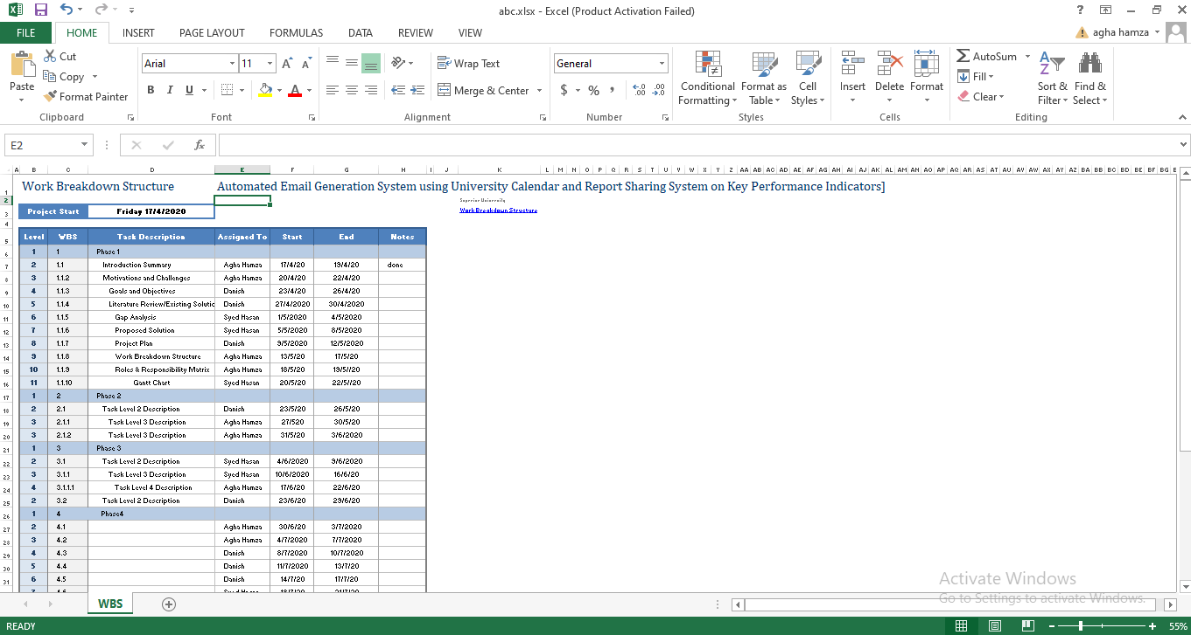

## Gantt Chart

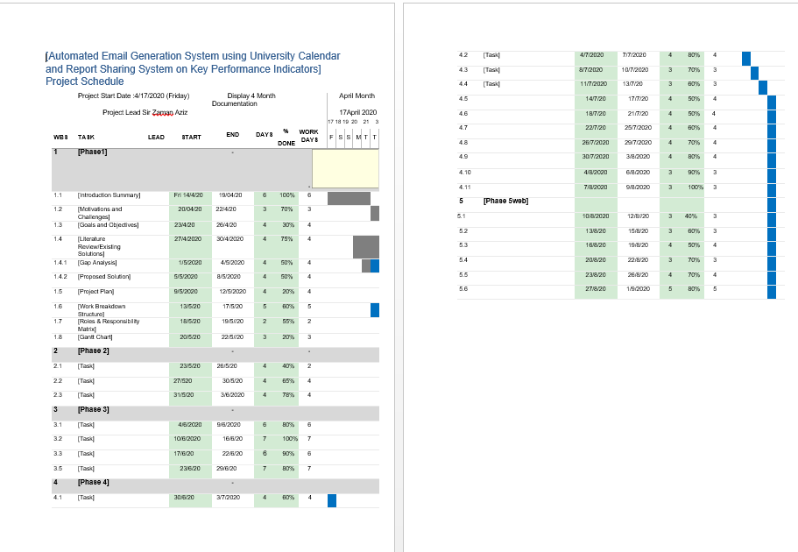

## Report Outline

[Paragraph Text 12 pt, Calibri, 1.5 Line Spacing, Justified]